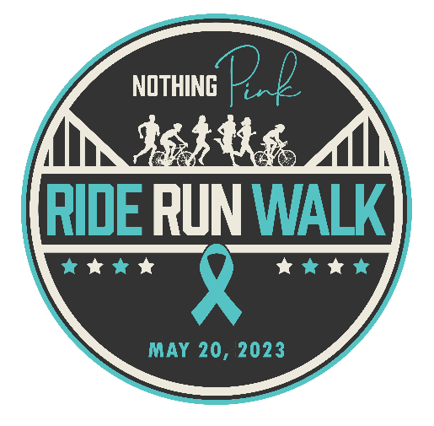

EVENT DAY MEET-UPS
May 20th, 2023

Where When Activity Contact

Walter Elisha Park/Fort Mill Noon Walking Carrie Williams carrie@nothingpink.org

Riverwalk Greenway Trail 8am Walk or Run Richelle Calicott Rc@calicottmail.com
Rock Hill

Rock Hill Criterium 11am Road Cycle Richelle Calicott rc@calicottmail.com
Rock Hill

McAlpine Creek Greenway TBD Mountain/gravel TBD
Charlotte Cycling

Want to join us? Please reach out to the contact provided for your desired meet-up location so they can add you to the list and keep you posted on the specifics.

We will provide additional meet-up spots and details in the coming weeks.

