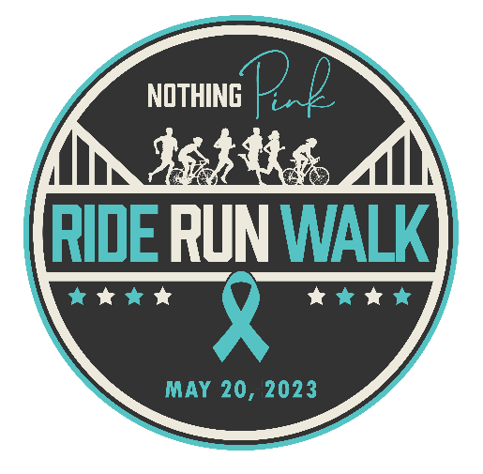

Qualifications for Giveaways, Prizes, & Awards

Event T-shirt and Swag Bag: Registered participants must raise a minimum of $200 in support of NothingPink.org to receive the event t-shirt and swag bag. Local pickup required.
All fundraising dollars must be submitted by 2pm on May 20th, 2023.

Various Awards and Prizes: Registered participants must raise a minimum of $200 in support of NothingPink.org to be eligible to win various prizes.
All fundraising dollars must be submitted by 2pm on May 20th, 2023.

Performance Apparel: Registered participants must raise a minimum of $1000 in support of NothingPink.org.
All fundraising dollars must be submitted by 2pm on May 20th, 2023.

Award: Proof of date and mileage must be sent via GPS tracking device. Multiple entry sessions
Most Miles logged on Foot are allowed for the time-period of 8am-2pm on May 20, 2023. (Smart Watch, GPS, or another device). All times must be submitted by 2pm on May 20th, 2023. Please note we will do our best to validate all entries, but only one participant will receive this award.
Award:
Most Miles logged on Bike Proof of date and mileage must be sent via GPS tracking device or website (Smart Watch, GPS, or other device). Multiple entry sessions are allowed for the time-period of 8am-2pm on May 20, 2023. All times must be submitted by 2pm on May 20th, 2023. Please note we will do our best to validate all entries, but only one participant will receive this award.

Prize: Registered participants must raise a minimum of $2000 to be eligible for this prize.
Top Fundraiser All fundraising dollars must be submitted by 2pm on May 20th, 2023. Please note, a maximum of one registered participant will receive this prize.

